Data Processing System: Concurrency and Exception Handling Report

Sri Sai Palamoor
MSCS-632-M80
Assignment 6

Nov 28 2025

Abstract
This report summarizes the concurrency models and exception handling strategies applied in implementing a multi-threaded Data Processing System in Java and Go. The system processes tasks in parallel using multiple worker threads/goroutines, ensures safe access to shared resources, and logs activity and errors. The report also compares the approaches used in Java and Go, highlighting differences in language-level concurrency models.

1. Introduction
The Data Processing System simulates multiple workers retrieving tasks from a shared queue, processing them, and storing results. The project demonstrates:
- Safe concurrent access to shared resources
- Proper termination of worker threads/goroutines
- Exception and error handling
- Logging for debugging and system monitoring
The implementations in Java and Go showcase the idiomatic concurrency patterns of each language.

2. System Design

2.1 Shared Queue
- Java: SharedQueue<T> uses ReentrantLock and Condition to protect the queue. Workers block on an empty queue until signaled. A close() method notifies all workers that no more tasks will arrive.
- Go: A channel serves as the concurrency-safe queue. Workers range over the channel until it is closed and drained.

2.2 Worker Threads/Goroutines
- Java: Worker threads are managed using an ExecutorService. Each worker retrieves tasks, simulates processing with Thread.sleep(), and writes results to a synchronized ResultWriter.
- Go: Goroutines run worker functions that read from the tasks channel, process data, and send results on a buffered results channel.

2.3 Result Handling
- Java: Results are written to a shared List<String> with synchronized access and later persisted to a text file.
- Go: Results are collected in a slice protected by a sync.Mutex and written to a file using defer to ensure proper closure.

3. Concurrency Techniques
Feature | Java | Go
Concurrency primitives | ReentrantLock, synchronized blocks, ExecutorService | Goroutines, channels, WaitGroup, mutex
Blocking/waiting | Condition.await() and signal() | Range over channels; blocking is implicit
Deadlock prevention | Localized locking, avoid nested locks, proper close() signaling | Channels and WaitGroup ensure proper shutdown; avoids complex locking
Thread/goroutine management | ExecutorService controls thread lifecycle | Goroutines lightweight, WaitGroup coordinates completion

4. Exception and Error Handling
- Java: Uses try-catch blocks to handle InterruptedException, IOException, and unexpected processing errors. Resources are released via try-with-resources.
- Go: Functions return errors which are checked immediately. defer ensures files and resources are closed even if a function exits early. Fatal errors terminate the program gracefully.

5. Differences Between Java and Go Concurrency Models
- Java: Thread-based, lock-oriented, more explicit control over synchronization. Higher risk of deadlocks if locks are mismanaged.
- Go: Message-passing concurrency model using channels. Lightweight goroutines reduce complexity; implicit blocking simplifies synchronization. Go encourages structured concurrency and reduces boilerplate for safe parallelism.

6. Sample Output
Java:
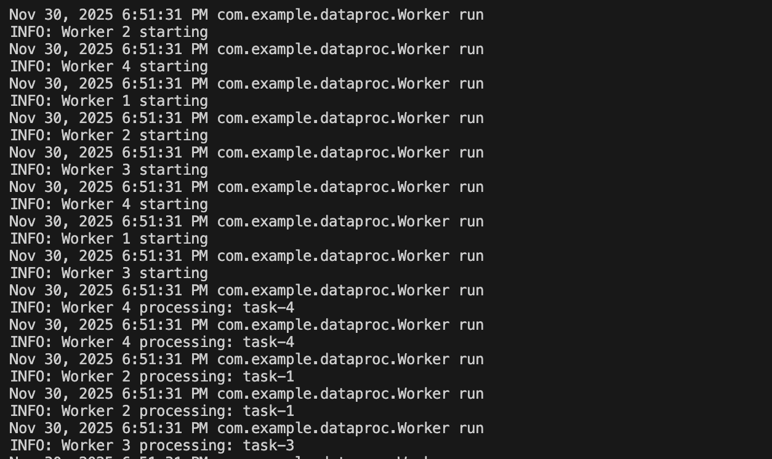

Go:
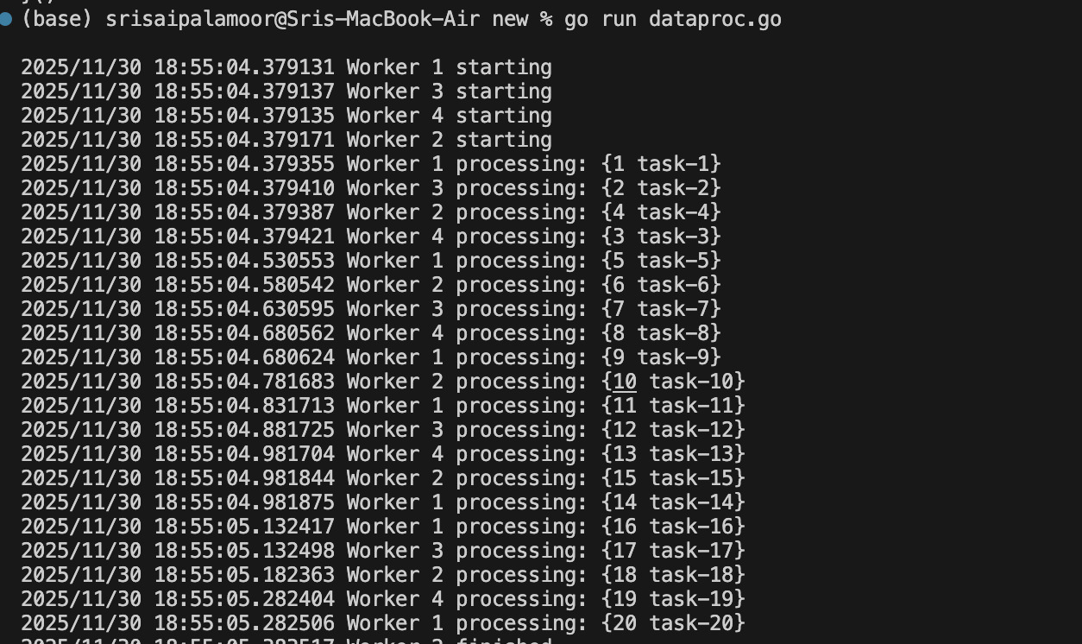

Sample code:

Java — Shared Queue with Locking
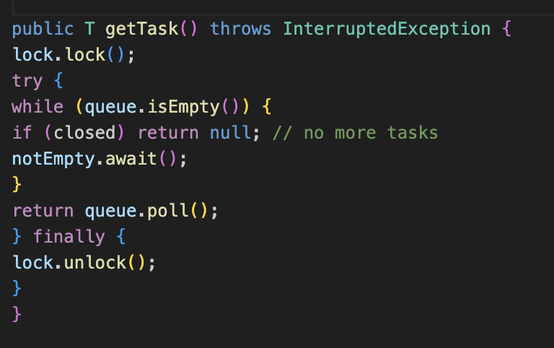

- Demonstrates ReentrantLock + Condition.await()
- Shows safe access to shared resources

Go — Worker Goroutine with Channels
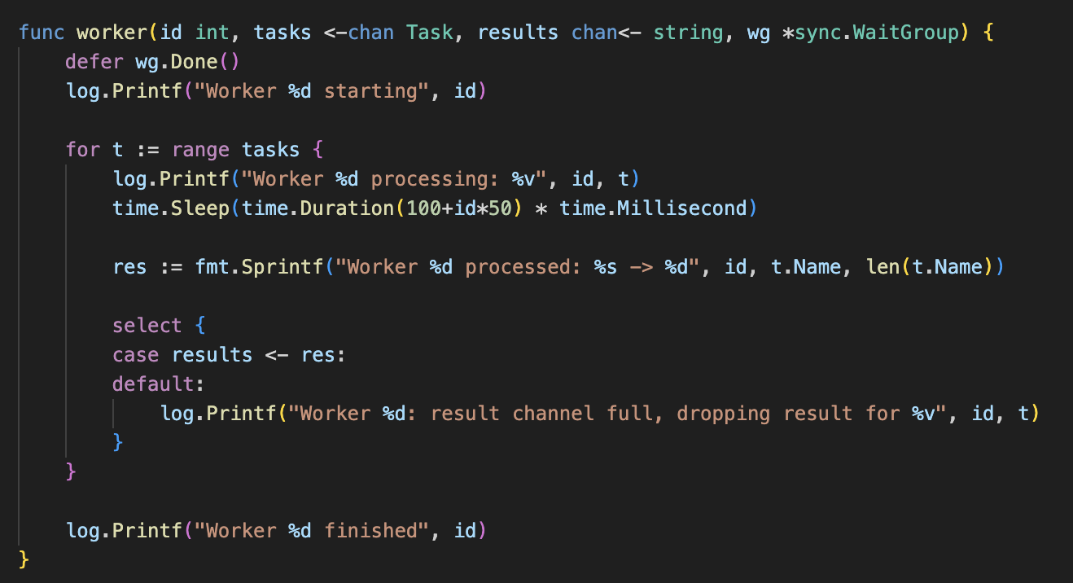
- Demonstrates Go’s channel-based concurrency
- Implicit safe access (no locks needed)

7. Conclusion
Both implementations achieve safe concurrent processing and robust error handling. Java provides fine-grained control with explicit locks, while Go simplifies concurrency through channels and goroutines. Each approach illustrates the idiomatic practices and advantages of the respective language’s concurrency model.

